Plots and Trends: Power BI Masterclass

Solutions Manual Exercise 1

Table of Contents

Getting Started 3

Loading Data 3

Editing Queries 4

Data Relationships 5

Changing Data Format & Properties 7

Exercise 1.1 9

Creating a Gauge Chart 9

Creating a Treemap Chart 9

Creating a Card Visual 9

Creating a Multi-row Card Visual 9

Creating a Waterfall Chart 9

Output 9

Exercise 1.2 11

Creating the Map Visual 11

Creating the Gauge Chart 11

Creating the Line Chart 11

Creating the Treemap 12

Creating the Matrix Visual 12

Creating the Slicers 12

Adding Shapes & Title 12

Output 13

# Getting Started

*This section serves as a general guide or reference to the basics that will be used often in PowerBI. The actual solutions to the exercises can be found in the later sections of this manual.*

## Loading Data

*PowerBI is bundled with a wide variety of data connectors that allows you to access your data easily.*

**IMPORTANT:**

PowerBI automatically determines the data types of your fields by looking at its values.

*Refer to the* *Changing Data Format & Properties**section for more information.*

1. Click on **Get Data** on the ribbon

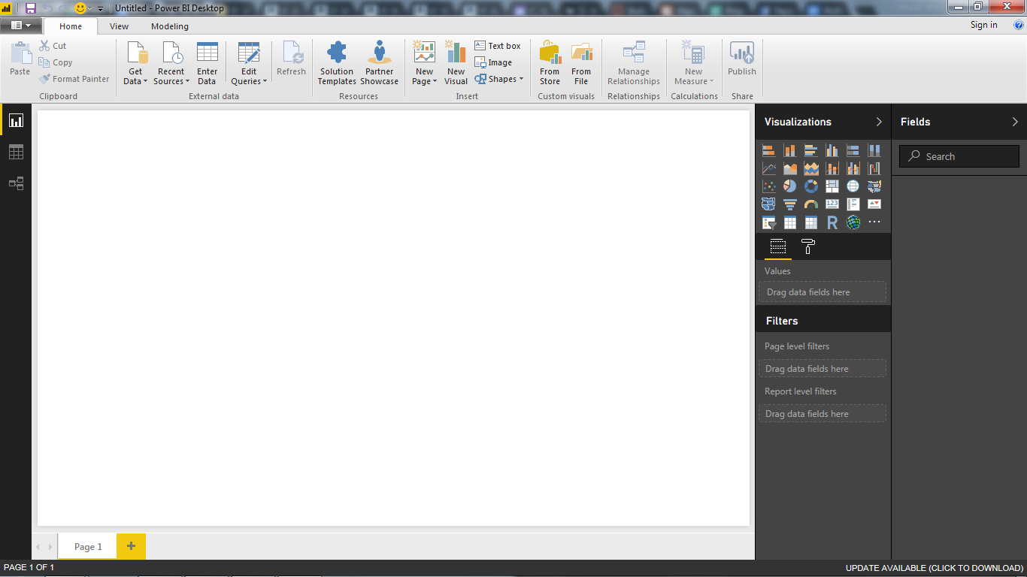

1. Select the data source type in the dialog and then click **Connect**.

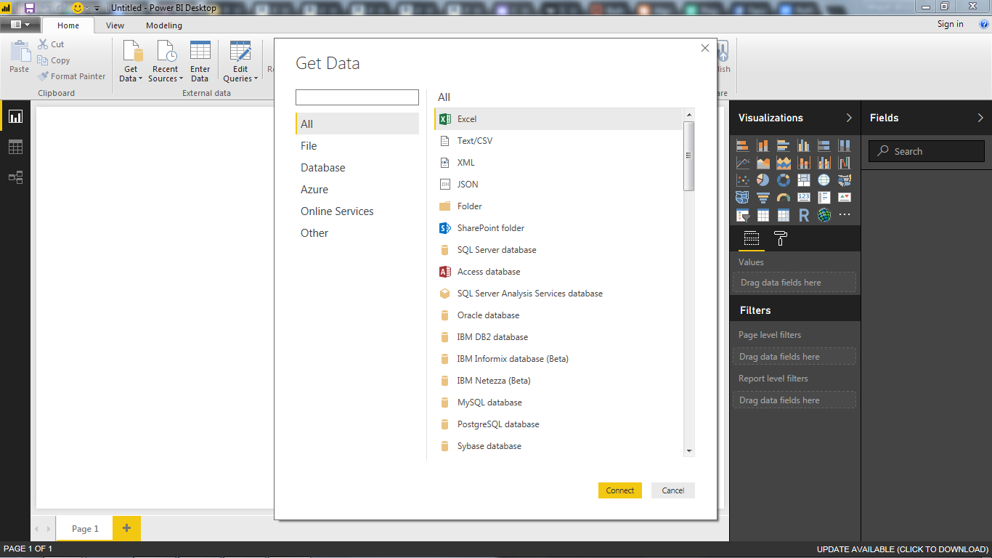

* + If you selected a file type, browse for the file’s location and then click **Open**.
  + If you selected a database, enter your credentials and then click **OK**.

1. Select which tables to add using the *Navigator* pane by clicking on the check beside its name and then click **Load**.

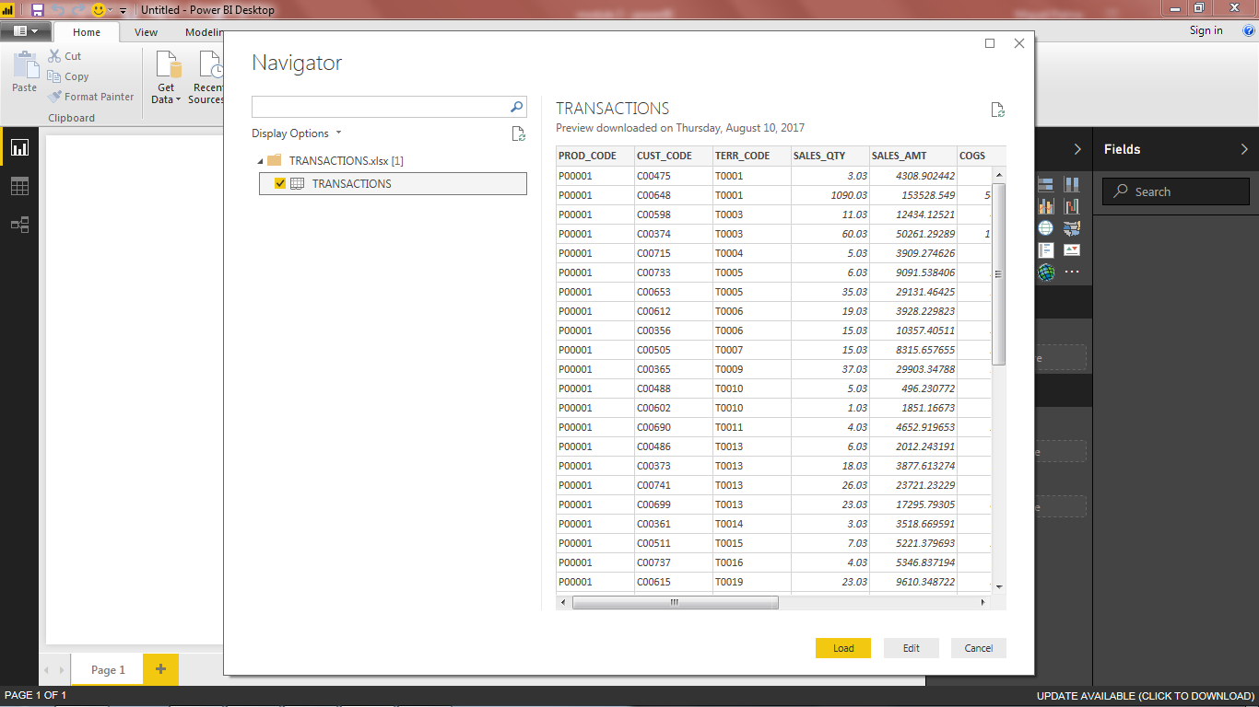

* + If you want to make adjustments to the data loading procedure, click **Edit**.
  + Then, refer to the next section on *Editing Queries*.

## Editing Queries

*PowerBI’s query engine is actually PowerQuery under the hood. Leverage the same powerful ETL query language to transform and prepare data for loading.*

**IMPORTANT:**

The “queries” that you produce in PowerBI’s query editor become the tables in your data model.

1. Click on **Edit Queries** on the ribbon.



* + If you clicked on **Edit** in the *Loading Data* procedure, skip this step.

1. Select the query you wish to edit from the *Queries* Pane on the left side of the screen.
2. Perform the adjustments to the loading procedure as you would do using PowerQuery.

## Data Relationships

*Data Relationships are an essential component to making effective and interactive reports in PowerBI.*

**IMPORTANT:**

PowerBI attempts to automatically determine data relationships present in your data by looking at fields with the same name and data type.

### Adding Data Relationships

#### Method #1: Manage Relationships dialog

1. Click on **Manage Relationships** on the ribbon.

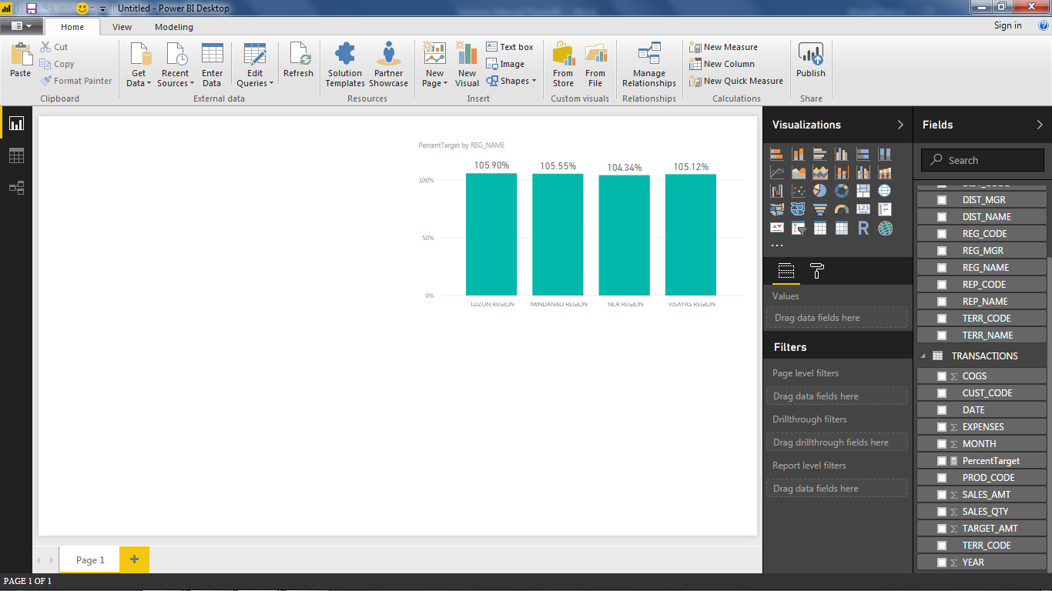

1. Click on **New** in the dialog box that appears.

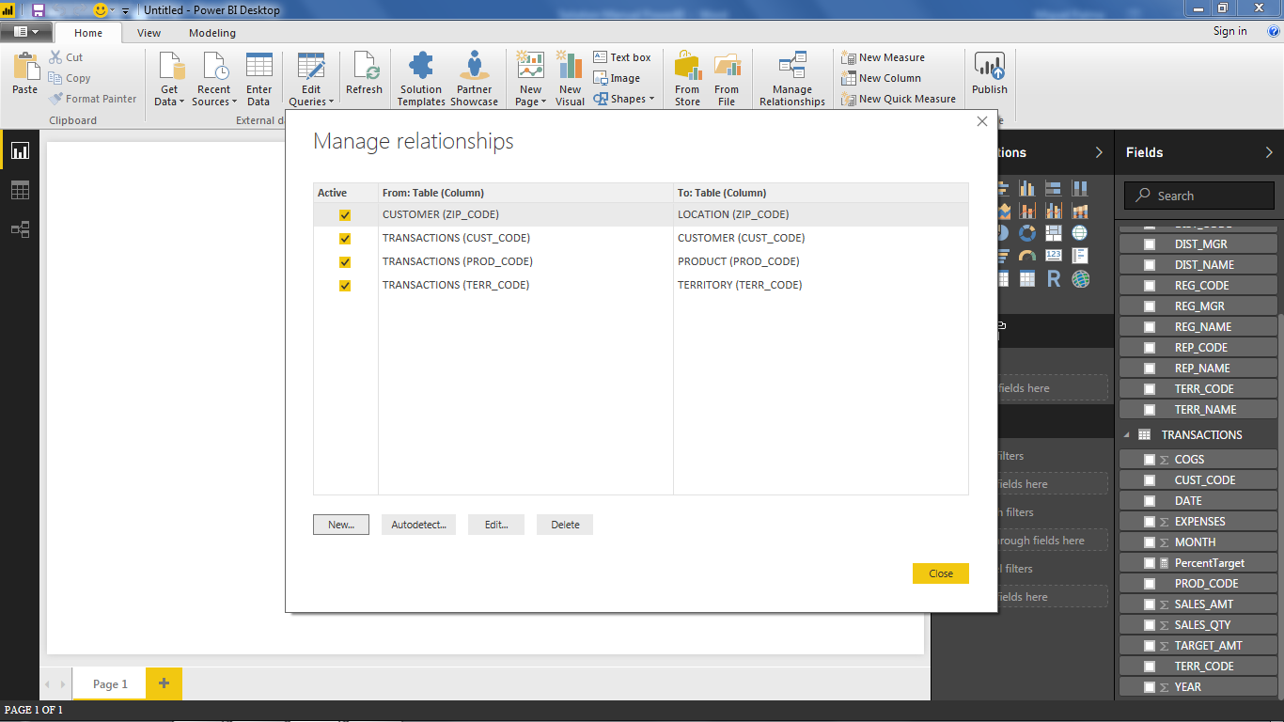

1. Select the tables which you will be adding a between. If PowerBI recognizes a shared field, it will automatically select the related columns and fill out the properties but you may choose to override this.

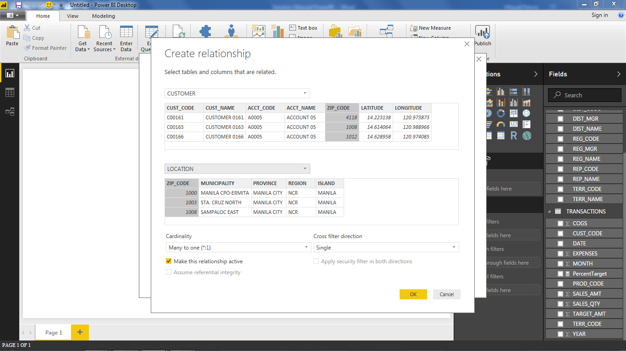

1. Click **OK**

#### Method #2: Relationships View

1. Go to the **Relationships View**.
2. Find the tables that you wish to relate. Click on the field in the first table and drag it all the way to the field in the second table and release.
3. PowerBI will then detect if a valid relationship can be formed using the two fields and then detects the cardinality.

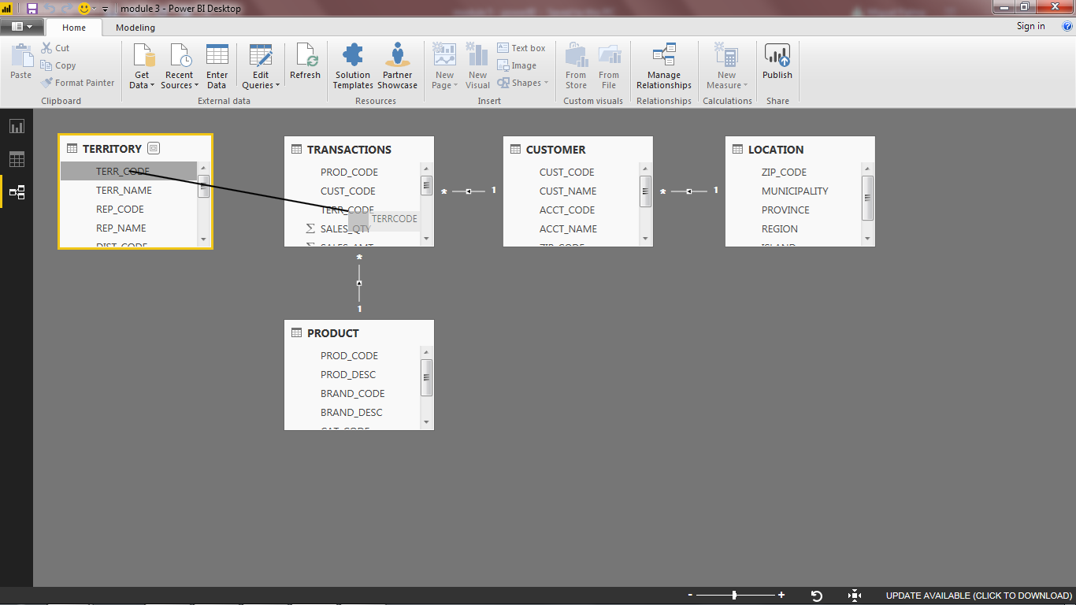

### Editing Data Relationships

#### Method #1: Manage Relationships dialog

1. Click on **Manage Relationships** in the ribbon.
2. Select a relationship in the dialog box and then click **Edit**.
3. Change the relationship properties such as the related columns and cardinality using the dialog box.

#### Method #2: Relationships View

1. Go to the Relationships view.
2. Double click on the line that represents the relationship you wish to edit.
3. Change the relationship properties such as the related columns and cardinality using the dialog box.

### Deleting Data Relationships

#### Method #1: Manage Relationships dialog

1. Click on **Manage Relationships** in the ribbon.
2. Select a relationship in the dialog box and then click **Delete**.
3. Confirm the deletion of the relationship**.**

#### Method #2: Relationships View

1. Go to the Relationships view.
2. Right click on the line that represents the relationship you wish to remove and then click Delete.
3. Confirm the deletion of the relationship.

## Changing Data Format & Properties

*The data properties also play an important role in setting the look and interactivity of your reports.*

**IMPORTANT:**

The *data type* of a field determines what type of operations can be done on it. (e.g. you can’t add (+) two text type fields together)

The *formatting* of a field determines how the data will be displayed. (e.g. the number of decimal places of a number or date formats such as YYYY-MM-DD)

The *data category* is an additional piece of information that you specify to help PowerBI use the data. Examples of data category are: city, country, latitude, longitude, etc.

The *default summarization* is the aggregation operation that PowerBI will immediately use when you add the field to a chart. (e.g. sum, average, minimum, maximum)

1. Click on the **Modelling** tab in the ribbon.
2. Select the field that you wish to edit in the *Fields pane*.
3. Change the data type, format, category, and default summarization of the field by using the objects in the ribbon.

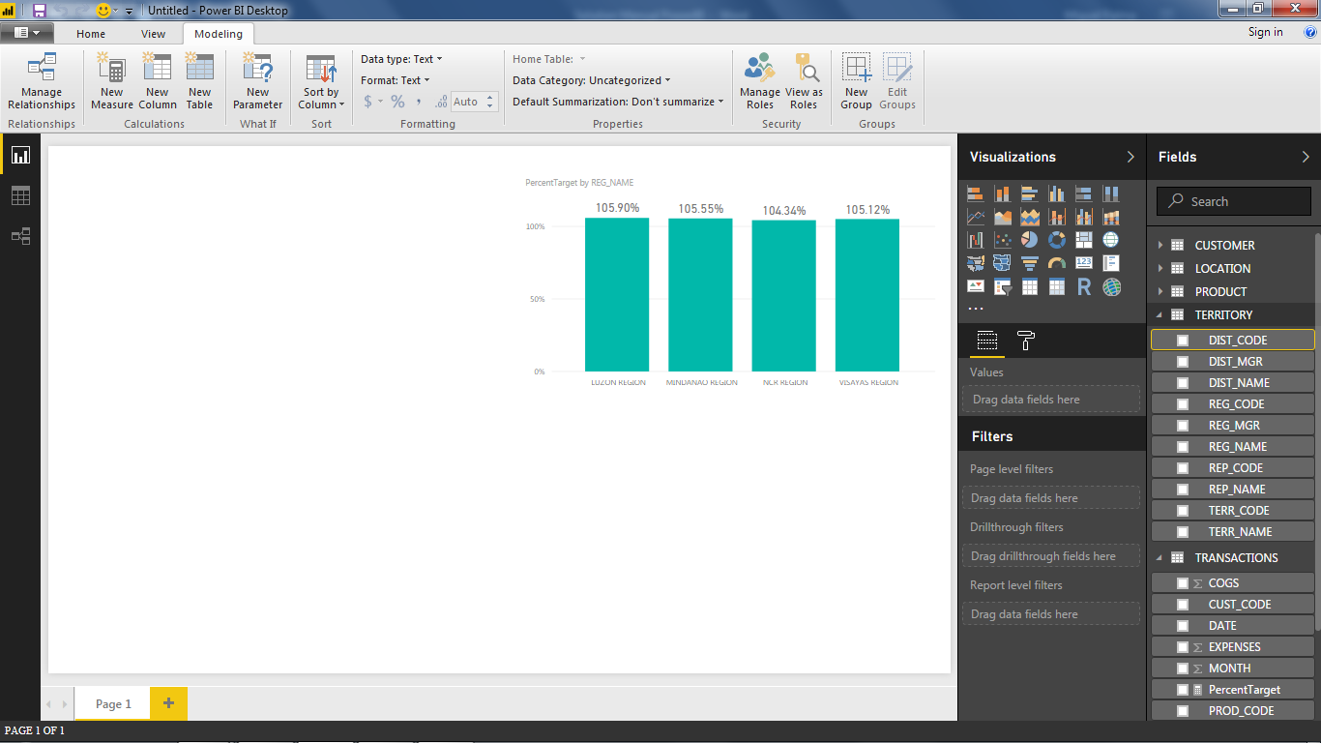

# Exercise 1.1

*The solutions here assume that the sample dataset that was provided is being used. Additionally, the configuration of fields used in the solutions are not the only way to produce the required charts.*

## Creating a Gauge Chart

*A Gauge chart requires numeric data fields for the Value, Target Value, Minimum Value, and Maximum Value.*

1. Click on **Gauge** in the *Visualizations pane*.
2. Drag *SALES_AMT* to *Value* and then drag *TARGET_AMT* to *Target Value*.

## Creating a Treemap Chart

*A Treemap chart requires a numeric data field for Values and Color Saturation. Text-typed fields are recommended for the Group and Details but numeric and date data fields are also allowed.*

1. Click on **Gauge** in the *Visualizations pane*.
2. Drag *SALES_AMT* to *Value* and then drag *TARGET_AMT* to *Target Value*.

## Creating a Card Visual

*A Card visual can accept numeric, date, and text data types but can only show one value.*

1. Click on **Gauge** in the *Visualizations pane*.
2. Drag *SALES_AMT* to *Value* and then drag *TARGET_AMT* to *Target Value*.

## Creating a Multi-row Card Visual

*A Multi-row card visual can accept both numeric, date, and text data types.*

1. Click on **Gauge** in the *Visualizations pane*.
2. Drag *SALES_AMT* to *Value* and then drag *TARGET_AMT* to *Target Value*.

## Creating a Waterfall Chart

*A Waterfall chart requires numeric-typed fields for the Y-Axis. Text or date typed fields are recommended for the Category and Breakdown but numeric fields are also allowed.*

1. Click on **Gauge** in the *Visualizations pane*.
2. Drag *SALES_AMT* to *Value* and then drag *TARGET_AMT* to *Target Value*.

## Output

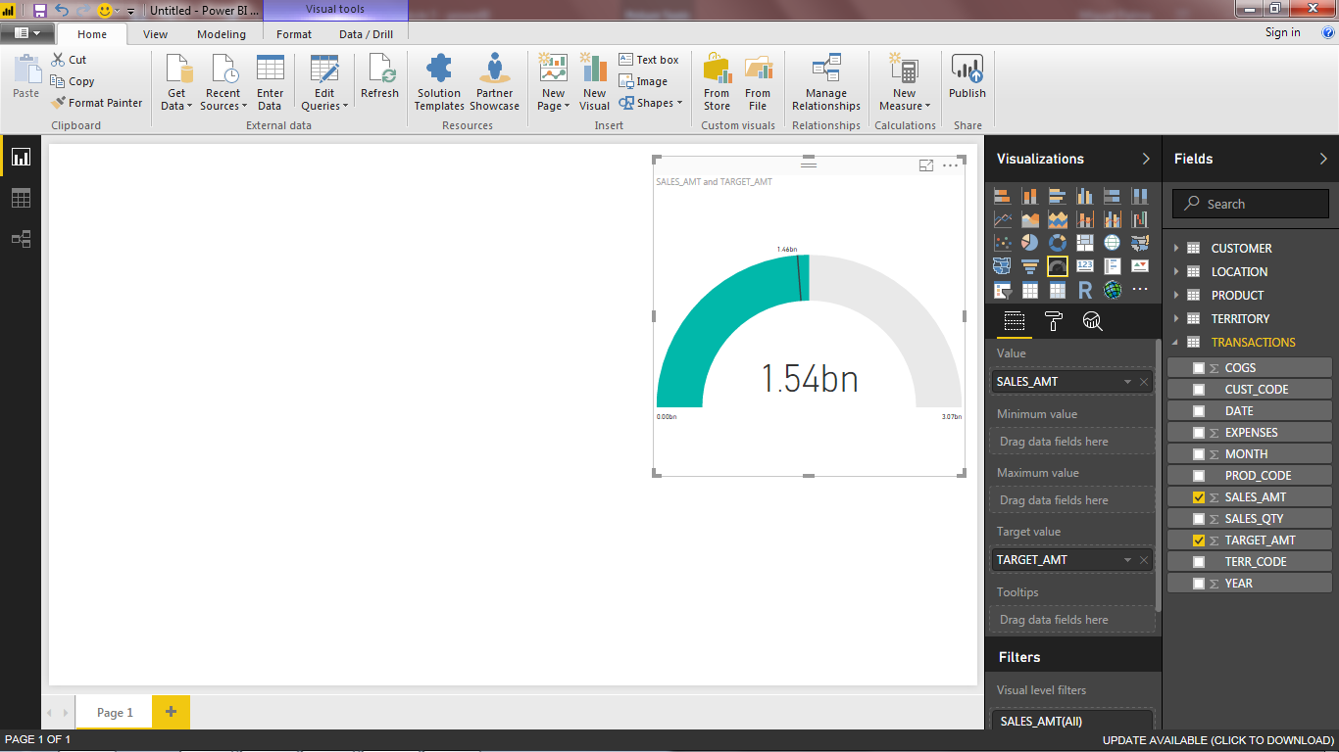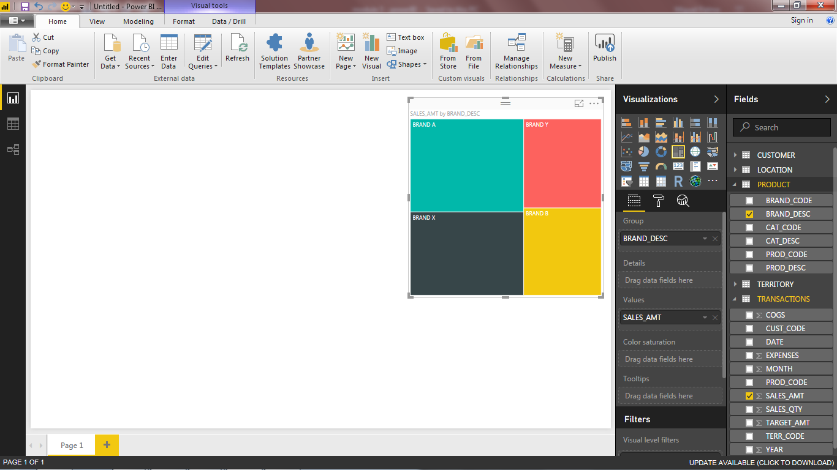

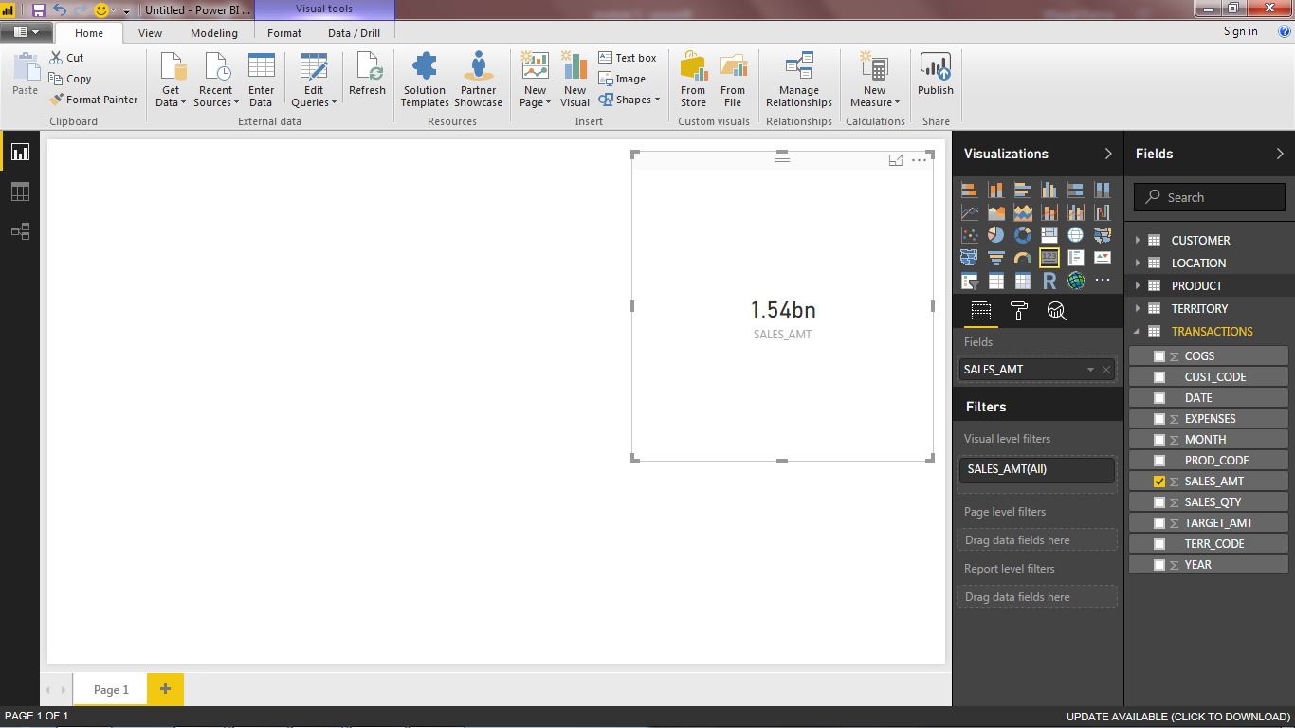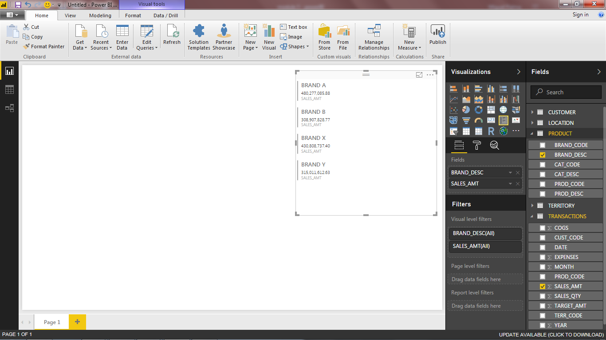

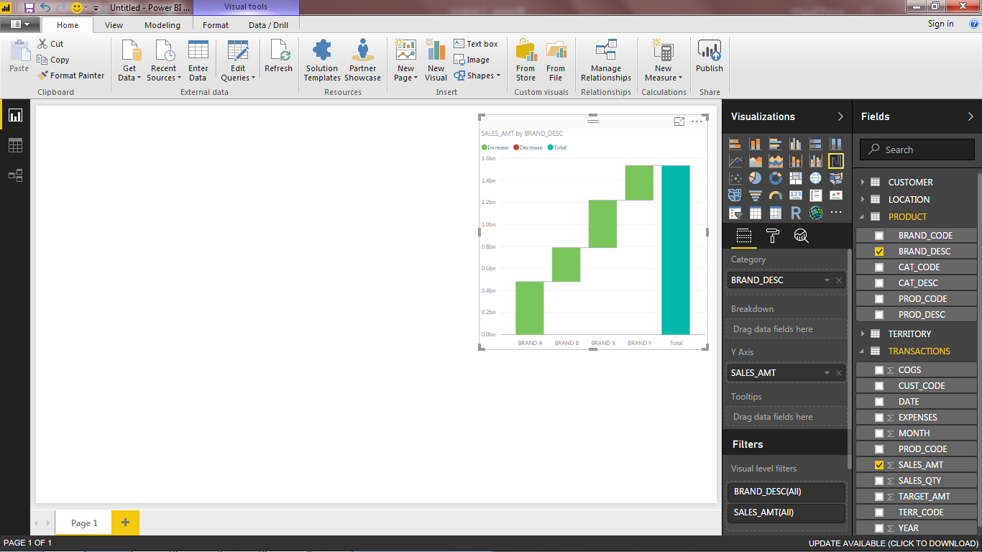

# Exercise 1.2

*This exercise is given as a free exercise, meaning that there is no prescribed target output. The solution here will outline the steps needed to create the sample output.*

## Creating the Map Visual

*The Map visual is essentially a bubble chart where the location of the bubble on the axes correspond to its geographical location. It is effective in visualizing business metrics with a context of location.*

**IMPORTANT:**

We can easily use the *Map visual* from the data in oursample dataset because it includes *latitude* and *longitude* information per customer. If this data is unavailable, it is possible to use the *location* field instead but this is unreliable since it most often draws the bubble in places in other countries that share the same name (like Spain).

1. Click on **ArcGIS Maps for PowerBI** in the *Visualizations pane*.
2. Drag the LATITUDE and LONGITUDE fields of the CUSTOMER table to the Latitude and Longitude field of the visual. Also drag the ACCT_NAME from the CUSTOMER to the Color field and the SALES_AMT field of the TRANSACTIONS table to the Size field.

## Creating the Gauge Chart

*The Gauge chart used in the sample report page uses the same fields as the one in the solution of the first exercise. This helps demonstrate how visuals are more interactive when used with other visuals and elements in a report page.*

*The Gauge chart helps give an idea of how the business is doing in terms of its sales target instantly.*

1. Click on **Gauge** in the *Visualizations pane*.
2. Drag *SALES_AMT* to *Value* and then drag *TARGET_AMT* to *Target Value*.

## Creating the Line Chart

*The Line chart helps establish a context when looking at the report by providing a perspective on the historical sales of the products or customers involved.*

1. Click on **Line chart** in the *Visualizations pane*.
2. From TRANSACTIONS, drag *SALES_AMT* to *Values* and then drag *DATE* to *Axis*.
3. Add a trendline by going the *Analytics pane*, expanding the *Trend Line section*, and then click **+Add**.

## Creating the Treemap

*The Treemap chart is able to quickly inform the viewer on the relative contributions of each account to the total sales figure. It is also possible to drill down to the customer level by using a hierarchy.*

1. Click on **Treemap** in the *Visualizations pane*.
2. From CUSTOMER, drag *ACCT_NAME and CUST_NAME* to *Group* and then drag *SALES_AMT* to *Values*.

## Creating the Matrix Visual

*The Matrix visual allows the viewer to easily check the raw sales figures for the top 10 products in the set.*

1. Click on **Matrix** in the *Visualizations pane*.
2. From PRODUCT, drag *PROD_DESC* to *Rows* and then drag *SALES_AMT*, *SALES_QTY*,and *EXPENSES* to *Axis*.
3. Filter the visual so that only the top 10 products are displayed.
   1. Select the Matrix visual and go to the *Filters* *area* in the *Visualizations pane*.
   2. Under the *visual level filters*, expand the section of *PROD_DESC*.
   3. Change the filter type to *Top N*.
   4. Set the *Show items* value to 10 and drag the *SALES_AMT field to By Value*.
   5. Click **Apply Filter**.

## Creating the Slicers

*The Slicers allow the viewer to focus his/her analysis on a specific subset of interest in the dataset.*

### Date Slicer

1. Click on **Slicer** in the *Visualizations pane*.
2. From TRANSACTIONS, drag *DATE* to *Field.*

### Region and Province Slicer

1. Click on **Slicer** in the *Visualizations pane*.
2. From LOCATION, drag *REGION* to *Field* for the first slicer and drag *PROVINCE* to the *Field* of the second*.*

## Adding Shapes & Title

*The shapes and the title help visually organize and cluster the report elements to make it easier for the viewers to understand the data.*

### Adding the Rectangle

1. Click on **Shapes** in the *Insert* group in the ribbon and then click **Rectangle**.
2. Adjust the position and dimensions of the rectangle using the handles on the side of the object and its color in the *Visualizations pane* (now labeled *Format Shape*). To remove the outline of the shape, set the *transparency* value of the *Line* to 100%.

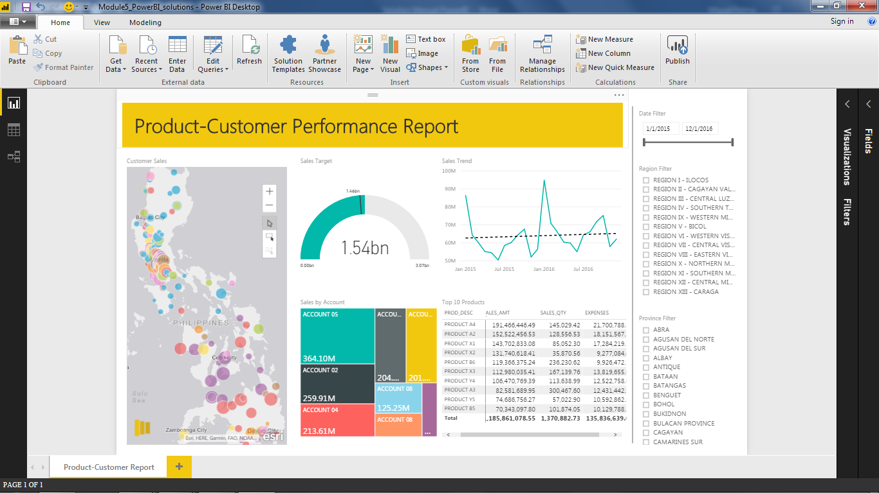

### Adding the Title

1. Click on **Text box** in the *Insert* group in the ribbon.
2. Adjust the position and dimensions of the text box using the handles on the side of the object and the font size, type, and color in the popup settings box, if needed.

### Adding the Line

1. Click on **Shapes** in the *Insert* group in the ribbon and then click **Line**.
2. Adjust the position and dimensions of the rectangle using the handles on the side of the object and its color in the *Visualizations pane* (now labeled *Format Shape*).

## Output

